1: solve it by dichotomy method and Bisection method
some hints：
import numpy as np
f=lambda x:2**x-4
f1=lambda x:np.log10(x)
f2=lambda x:x**0.5-1
def two_cen(head,end,fun):

in latin，regula falsi
some hints：
f=lambda x:2**x-4
f1=lambda x:x+1
f2=lambda x:x**0.5-1

def try_place(x0,x1,fun):
import numpy as np
f=lambda x:2**x-4
f1=lambda x:np.log10(x)
f2=lambda x:x**0.5-1
def two_cen(head,end,fun):
cen=(head+end)/2
while True:
if fun(cen)*fun(head)<0:
end=cen
elif fun(cen)*fun(head)>0:
head=cen
else:
return cen
least_cen=cen
cen=(head+end)/2
try:
if abs((cen-least_cen)/cen)<0.00005:
return cen
except ZeroDivisionError as e:
pass
pass
print(two_cen(-5,5,f))
print(two_cen(0.5,5,f1))

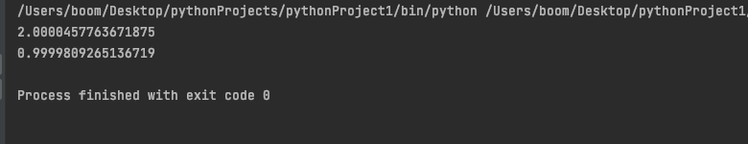

2: solve the roots of the equation through iteration methods，Newton，secant method
import numpy as np
import matplotlib.pyplot as plt
f=lambda x:2**x-4
xi=lambda x:x+1
xrange=lambda x:x**0.5-1
def try_place(x0,x1,fun):
xr=x1-fun(x1)*(x0-x1)/(fun(x0)-fun(x1))
while True:
if fun(xr)==0:
return xr
x0=xr
least_xr=xr
xr=x1-fun(x1)*(x0-x1)/(fun(x0)-fun(x1))
try:
if abs((xr-least_xr)/xr)<0.00005:
return xr
except ZeroDivisionError as e:
pass
pass
print(try_place(-1.5,1,f))
print(try_place(-5,5,xi))
